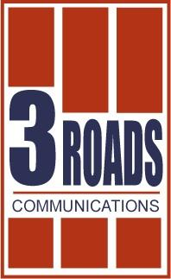

FOR IMMEDIATE RELEASE:

New Documentary Chronicles Heroic American Response to Refugee Crisis During the Armenian Genocide

They Shall Not Perish Premiers This April on Public
Television Nationally

Frederick, MD – March 6, 2017 – This April, public television stations across the country will premiere They Shall Not Perish: The Story of Near East Relief. The documentary is produced by Shant Mardirossian and award-winning writer/director George Billard. They Shall Not Perish details the unprecedented humanitarian efforts of thousands of Americans who saved a generation of orphans and refugees after the collapse of the Ottoman Empire during and after World War I.

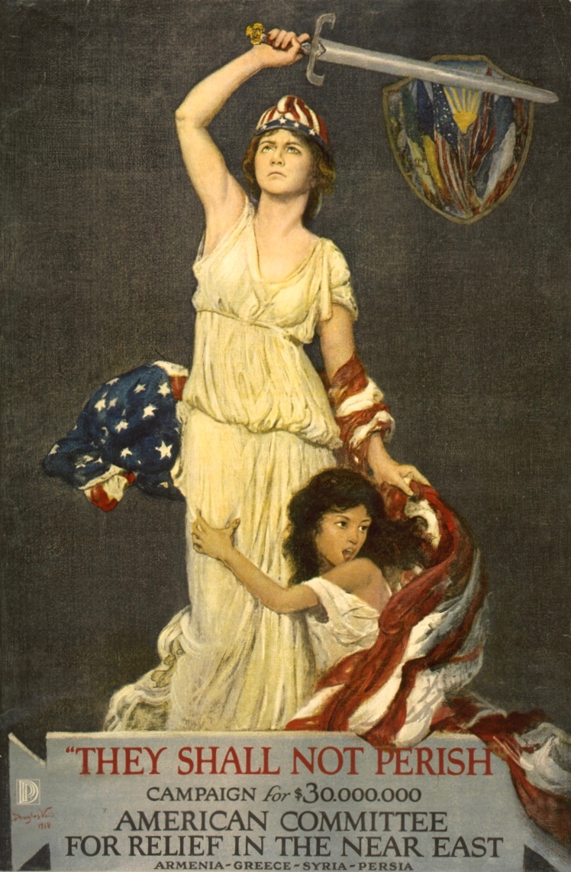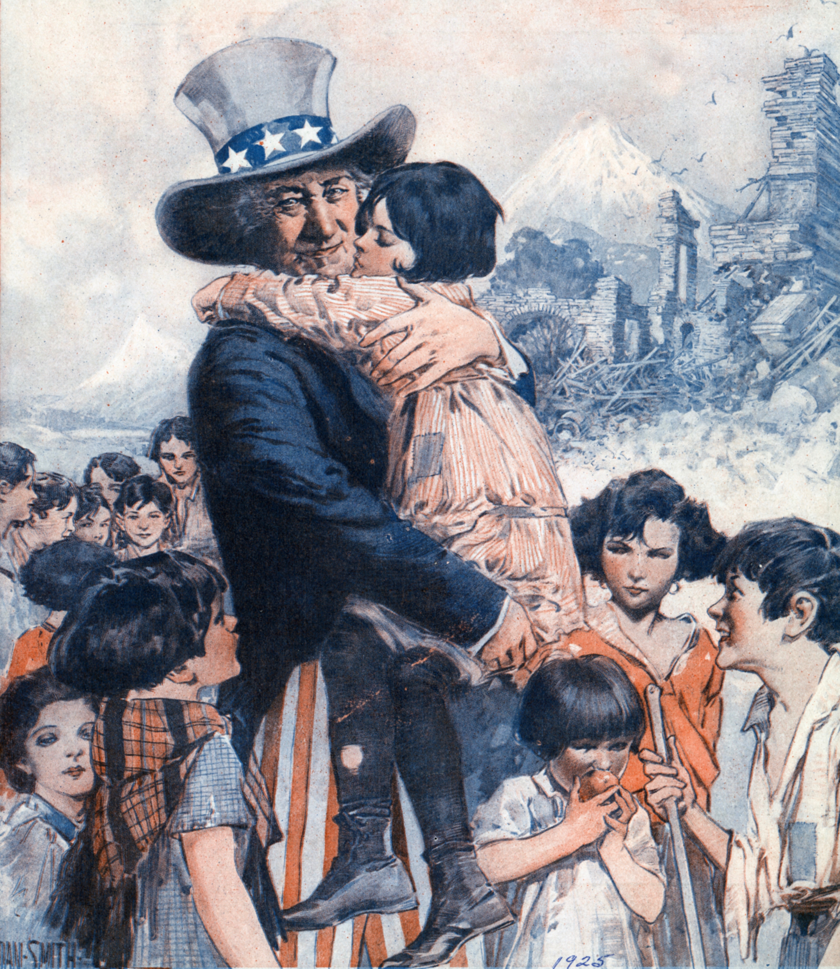

The one-hour documentary film features the stories of American diplomats, missionaries and relief workers who, as witnesses to the Armenian Genocide, responded to a call to action and mobilized the largest non-governmental international humanitarian movement undertaken by American citizens. Motivated by nothing but a moral sense of duty, these men and women – among them industrialists, ambassadors, teachers, nurses, advertisers and Presidents – helped bring care and comfort to millions of suffering refugees in extremely harrowing circumstances.

Narrated by six-time Emmy award nominated actor Victor Garber, the film is set against a mix of historical footage, archival photographs and utilizes contemporary interviews from leading academic experts such as Taner Akçam, Peter Balakian and Keith David Watenpaugh. In addition, the letters of American officials, relief workers and orphans are brought to life through the voices of leading actors – Michael Aronov, Kathleen Chalfant, Dariush Kashani, Andrea Martin, Ron Rifkin, Tony Shalhoub and Kara Vedder – taking the audience on a journey from the depths of cruelty to the triumphs of survival.

Executive Producer Shant Mardirossian, inspired by his grandparents’ escape and survival during the genocide, says he produced this film “not just to remember those we lost in the genocide, but to shed light on an important chapter of American history when ordinary citizens stood together against a great injustice and saved the lives of 132,000 orphans.” These historic rescue efforts led to the formation of the Near East Relief – known today as the Near East Foundation – an organization that continues to help improve the lives of vulnerable communities and refugees throughout the Middle East and Africa by implementing innovative, community-led economic development initiatives.

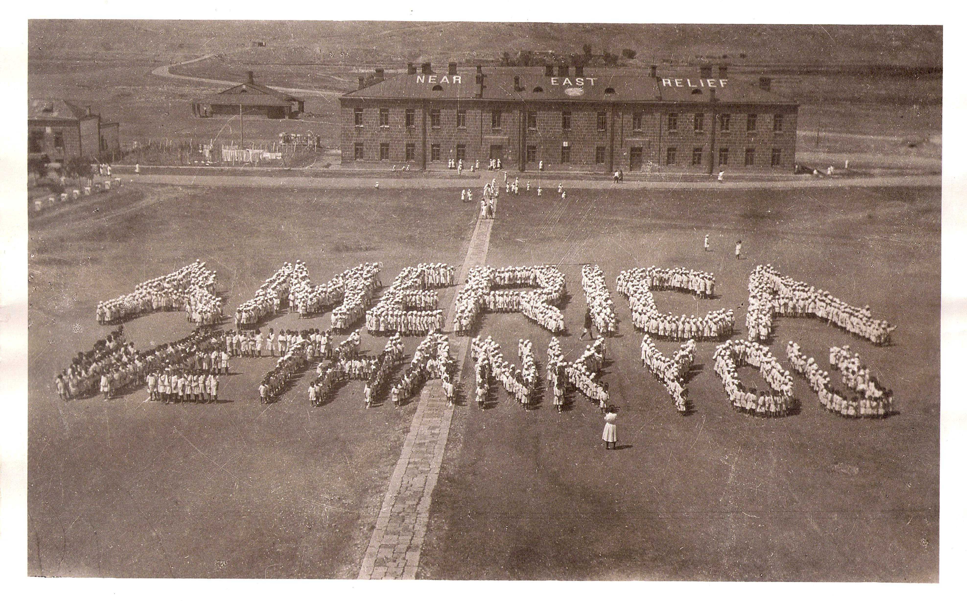

With a focus on an often forgotten yet important chapter in American history, They Shall Not Perish challenges the notion of what values a nation should aspire to demonstrate, and raises the question of when and if humanitarian concerns should override strategic national interests. “Today, as we confront an exploding refugee crisis, it’s imperative that we consider the humanitarian consequences when formulating U.S. foreign policy”, says the film’s director, producer and writer George Billard.

Distributed nationally by 3 Roads Communications, They Shall Not Perish premieres on public television stations nationwide beginning April 1, 2017.

The official premiere and discussion with the filmmakers will take place on April 8, 2017 at the Times Center – 242 W 41st Street, New York, NY. For details on purchasing tickets please visit www.neareast.org/theyshallnotperish or contact Andrea Crowley at acrowley@neareast.org or (315) 428-8670.

More information on the film, screenings and resources can be found at www.theyshallnotperish.com. The official press kit can be found at http://3roads.com/presskit/shall-not-perish. For media inquiries, please contact Russ Hodge of 3 Roads Communications at russ.hodge@3roads.com or (301) 662-4121.

###

