In Celebration of Women’s History Month
Dulles International Airport and Uniting US
Present the Artwork of Female Veterans

Check out Uniting US Video
Beginning Monday, March 15, in recognition of March as Women’s History Month, the thousands of travelers who journey daily through Dulles International Airport now will be able to savor the artwork of women veterans who use art making to achieve a sense of well-being.
The artists are women who have served their country in every aspect from military duty at the Pentagon to being deployed overseas to Iraq and Afghanistan. They have collectively seen and experienced everything from death on the battlefield to personal trauma.
Their unique artworks, which employs mediums from stretched porcine casing to burnt wood, will be on display near the AeroTrain station in Dulles’ C Concourse.
Says Michael Cabbage, manager of the airport’s art and exhibits program, “This is a terrific way to celebrate Women’s History Month and showcase the unique talents of this group of women. We’re honored to be joining with Uniting US to give well-deserved attention to these artists and their service to our country.”
Adds AnnMarie Halterman, Uniting US founder and Air Force veteran, “Uniting US is committed to helping our veterans build wellness and strength through their artistic talent. Consequently, we are profoundly grateful that Dulles International Airport is enabling us to share our artists’ unique perspectives and talents with the public.”
Below Are Some of the Artists Whose Works Will Be Displayed
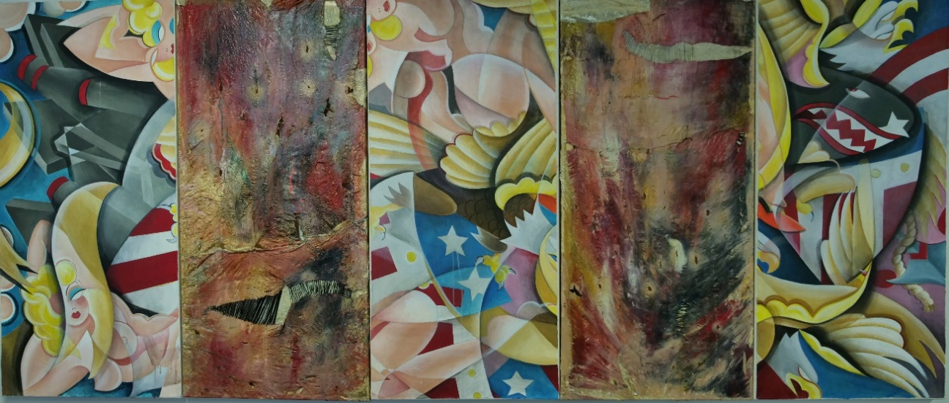
‘Til the Death, Leigh Cortez, Army Veteran
Five Panels, each 4’ x 12’ Acrylic on canvas, stretched bovine and porcine casing, ink, thread

Leigh Cortez, is both an Army veteran and spouse of an active-duty combat soldier. Cortez’s work examines the unpredictability, tension and trauma of military life. “I work both with destroying images indicative of the military tattoo subculture and with material intrinsically associated with destruction, such as the intestines of animals traditionally used for sausage preparation,” says Cortez, who is also a tattoo artist, “This material reacts with the mash of tattoo imagery painted on the canvas panels. Whereas the tattoo imagery questions a superficial narrative of military culture, the bovine intestine panels represent a more intimate reality of military life.”

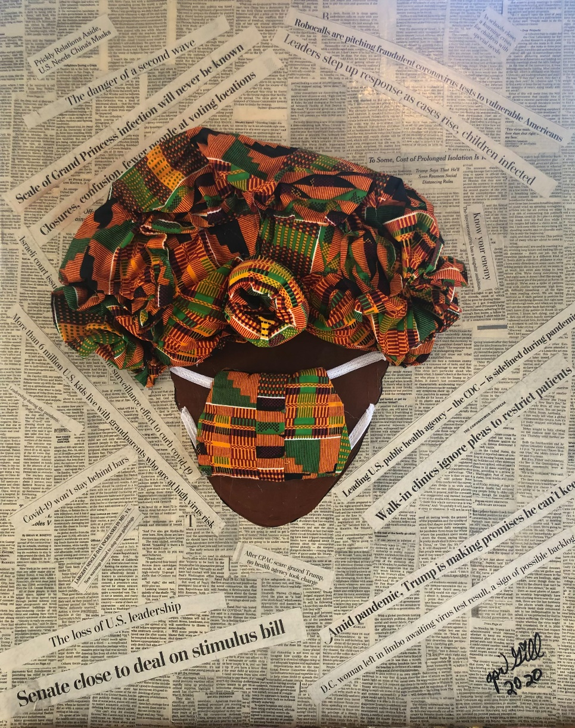

April Goodwin-Gill, an Army veteran, creates art from found objects. Cardboard cylinders or bottle caps can spark her recycling creativity. Her talents with a sewing machine are remarkable.
As part of the Uniting US Operation Mask Force national initiative with Quilts of Honor, Goodwin-Gill has been working diligently to help safeguard community members in the metro DC area. In addition to the stress of COVID-19, Goodwin-Gill has recently honored the anniversary of the death of her daughter. She hopes that her masks will help save the lives of many other children and keep others healthy to bring their families joy.

Mask Up April Goodwin-Gill, Army Veteran
24”x30” Fabric, newsprint, mixed media

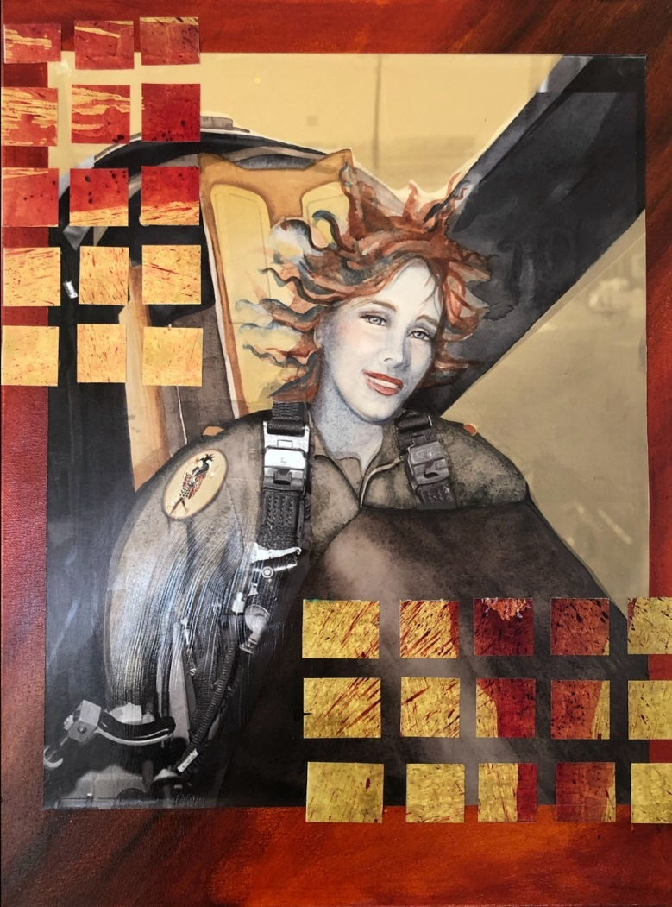
The Fool is the only Major Arcana card that is still at play in modern poker cards as The Joker. Concepts associated with The Fool are: Beginner’s Mind, Spontaneity, Adventure.

“This self-portrait is from a photo reference of when I got an incentive ride in an F-16 fighter. I changed my rank here to a butter bar, emblem of a beginner, and added the Joker patch to my flight suit. I also collaged a grid from segments of a painting by Imran Quereshi, a brilliant contemporary Pakistani artist, whose work speaks to the effects of war on his country,” says Cynthia Scott.

The Fool, Cynthia Scott, Air Force Veteran
18”x24” Digital and mixed media collage
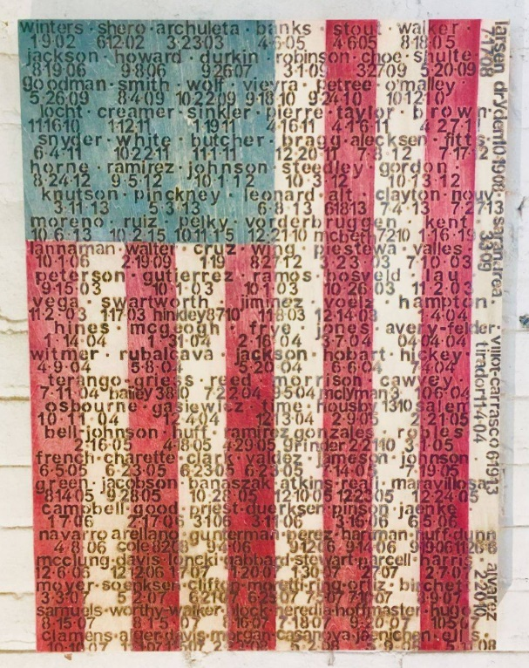
Her Voices contains the last names and dates of death for each of the female soldiers killed in action as part of the War on Terror, OIF, OEF, and most recently in Syria (2002 - 2019). “Their deaths aren't any more or less important than their male counterparts, however, Her Voices does confront and recognize that over 96 percent of the names burned into this patriotic surface are soldiers killed in combat before our country "officially allowed" women to serve on the front lines,” says Christina Helferich-Polosky

Her Voices, Christina Polosky-Helferich, Army Veteran
18’’x24’’x2’, Burned and Stained Wood

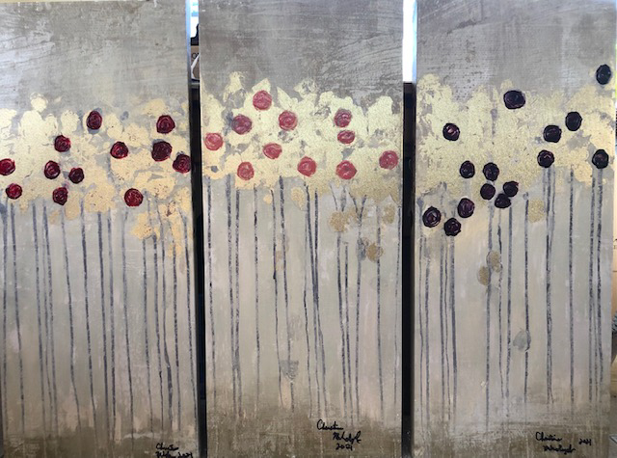
The Calm, Christine Mikolajczak, Navy Veteran
Triptych 45”x35” Mixed media on canvas panels

The Calm is a mixed media triptych painted on canvas panels. Christine Mikolajczak has been involved in art since she was a child. She continued to create art while serving in the military during the Cold War and credits much of her health and wellness to the healing power of the arts. Working in the Pentagon as a new service member, art was a saving outlet to help Christine process the stressful workload and constant work demands. She hopes viewers will take a few seconds to absorb the beauty and peace put forth from The Calm.

Prior to COVID, she was awarded a scholarship to take art related classes at a local college. “Taking the class was extremely therapeutic,” says Mikolajczak, “I thoroughly enjoyed this class and the social engagement, especially due to COVID isolation.” Art continues to unite Christine, other artists and all those who view her work despite the continued limitation caused by COVID.

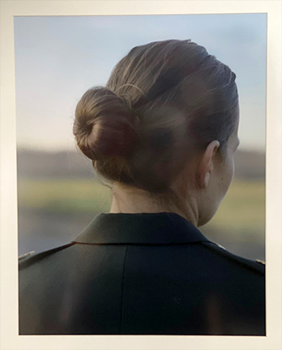
Spilt Milk, Amber Zora, Army Veteran
Photography

Spilt Milk is a self-portrait taken with a 4x5 large format camera using a shutter release cord. The image denies the traditional military portrait and male gaze.

I was deployed to Iraq as an ammunition specialist with the 592nd Ordnance Company from 2006-2007. After coming back from Iraq, I became a Public Affairs Specialist and joined the 314 PA Detachment. I received my Master of Fine Arts degree in Photography + Integrated Media from Ohio University in 2015.

I create art because it is an important process for me to understand the world. Art is a tool to convey stories and share histories. And I benefit from interacting with other veterans, specifically veteran women, who were moved by my work, had similar experiences and share their stories with me.

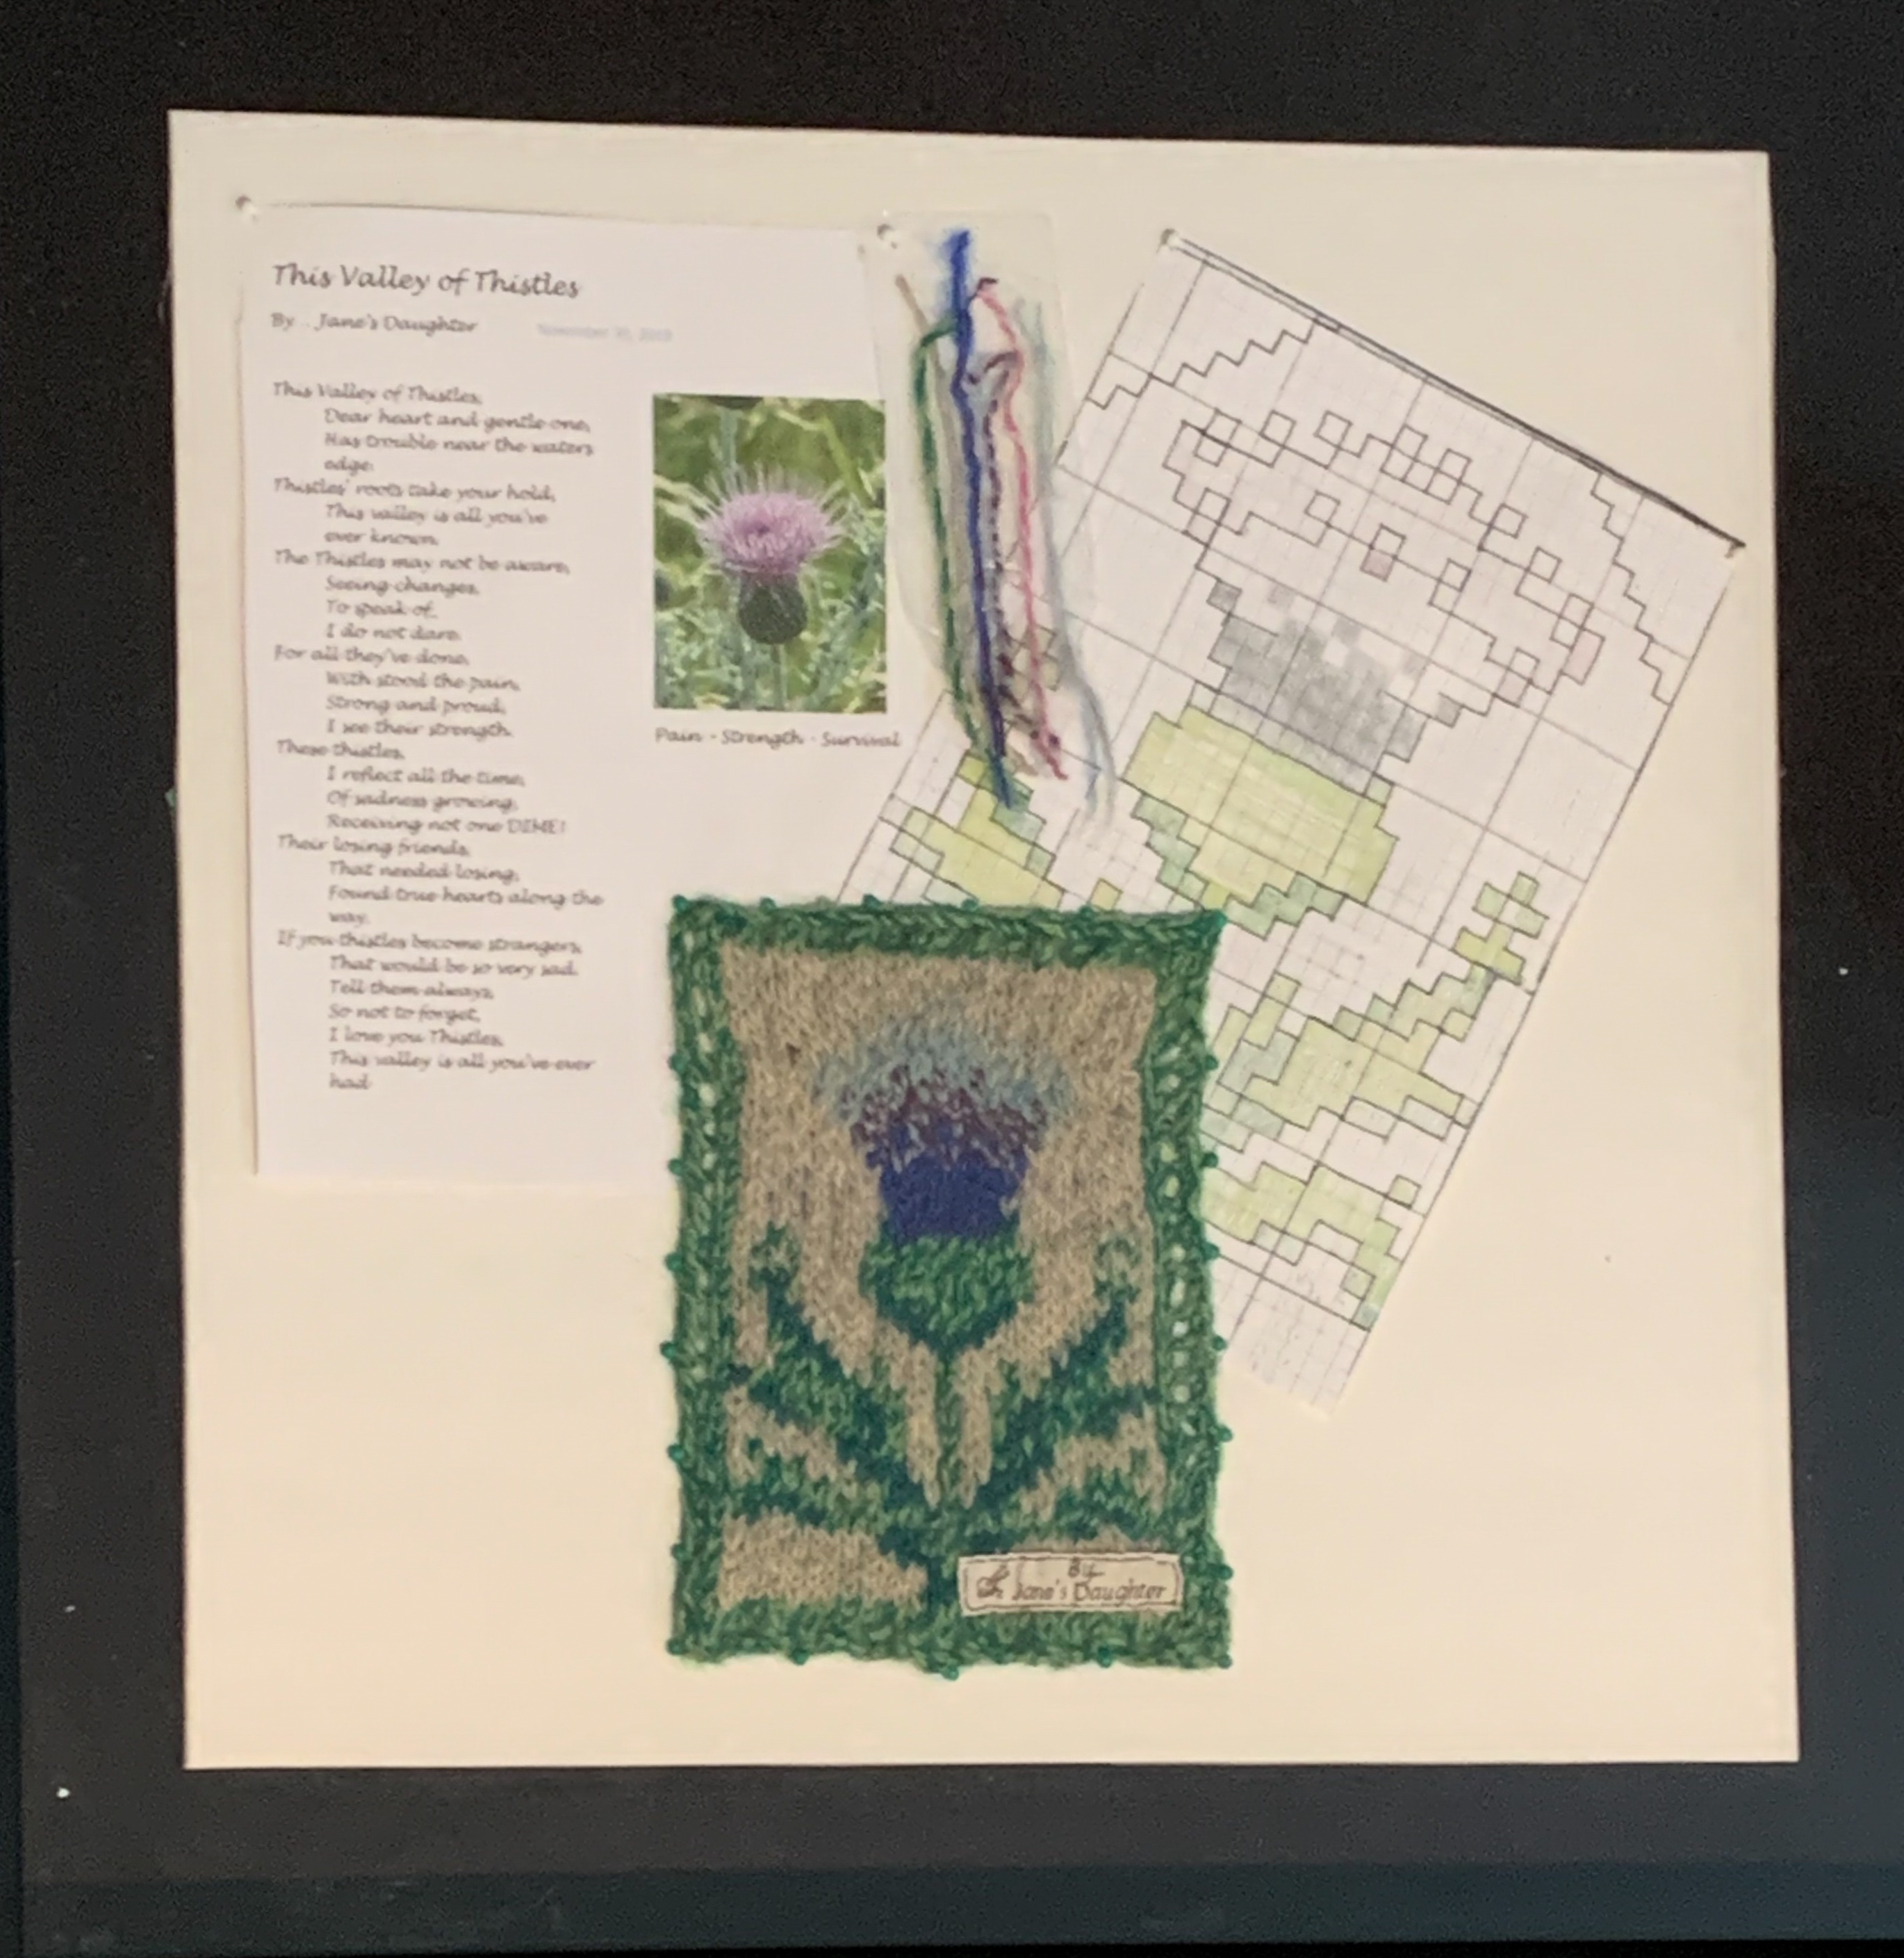
This Valley of Thistles, Mary Lopez Miller, Navy Veteran

This Valley of Thistles is a mixed media artwork created from raw materials turned into fabric and materials using practices centuries old. Through a combination of written word and visual representation, Mary Lopez Miller’s creations are a labor of love that require patience, dedication, and emotional investment.

Mary’s personal mantra “may what these hands make please you” is a consistent message to viewers as a means to invite meaningful discussion and greater understanding. Through personal loss, she found fiber art. Mary identifies as a wife, mother, sister, friend to many, Army veteran, former nurse, soldier always, a spinner/maker of yarn, a military trauma survivor and ultimately, she is Jane’s Daughter. Texture, coloring, and fiber qualities symbolize life's meaning, typically starting with a song, photos, or a poem that touches her. Dreams bring images of what she must make, so as not to forget those before her.

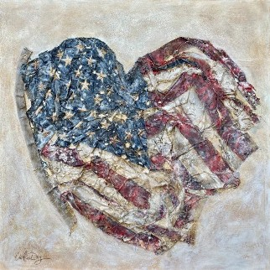

Love America, Cristin Dy, Air Force Veteran

Love America was created during a very chaotic time in our country. The painting reminds us that during our nation’s weakest moments, we can stay United through love, kindness and patience.

Within her almighty are scars and unrecoverable lost people, pieces, and places. This metaphor was replicated in Love America by the holes, faded colors and frayed edges. The old glory style artwork represents the heartache that Americans have endured through COVID, the presidential election, past times of war, suffering and loss. The image portrays that love preserves America and our place in the world.

